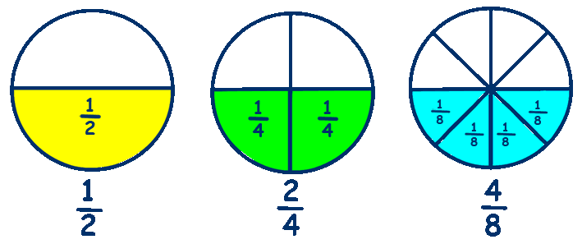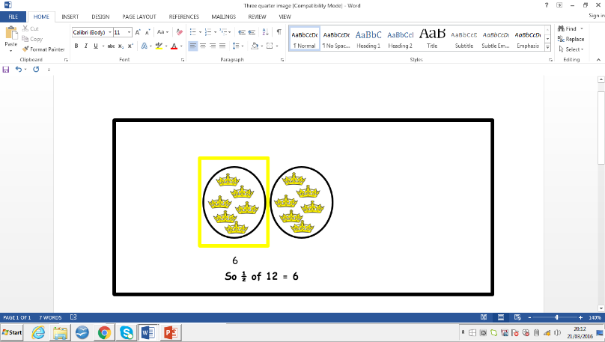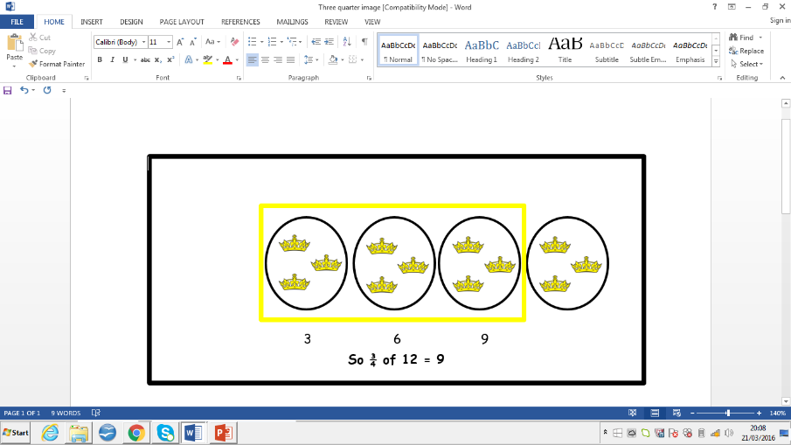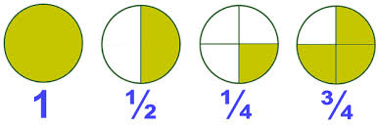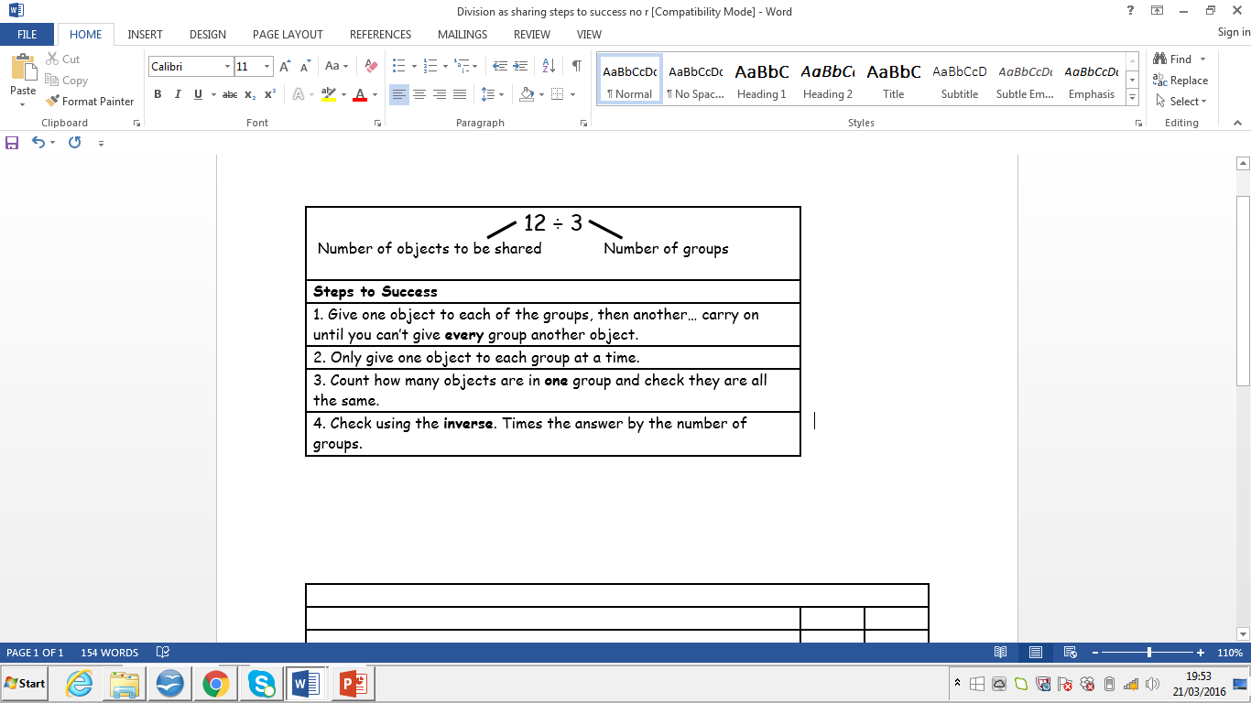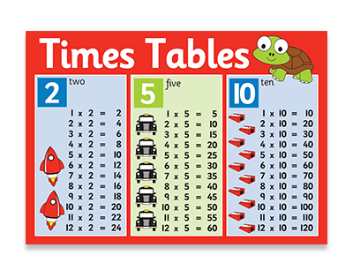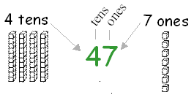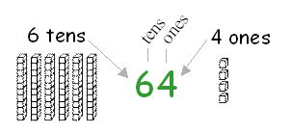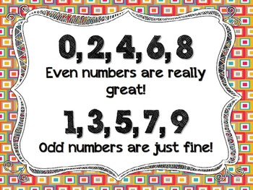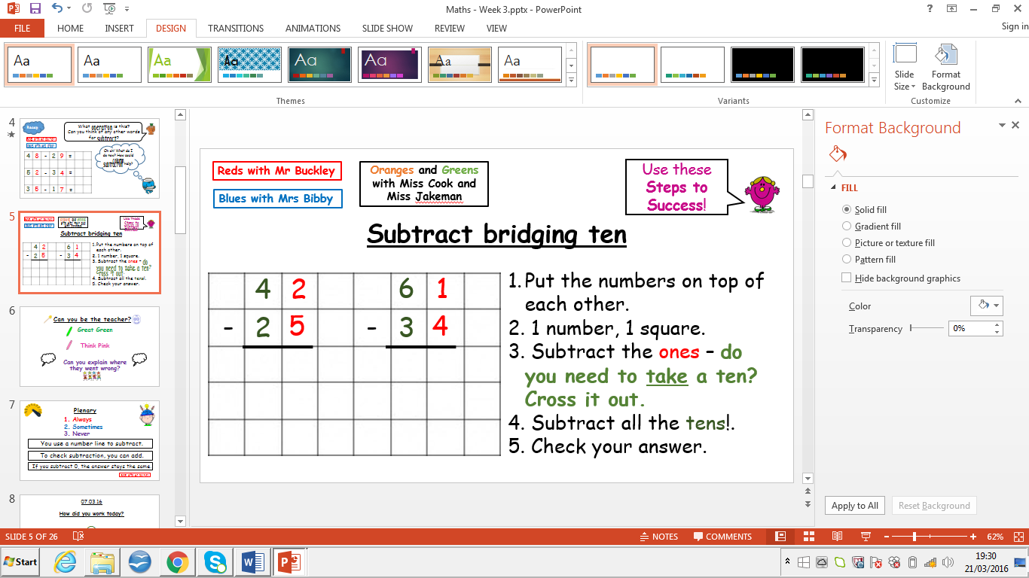

**Year Two Maths**



Make your answers perfect by checking them.

Don’t forget to follow the steps!

Can you apply what you know into a word problem?

These need to be known both in and out of order. If you have mastered these, try your **three** and **four** times tables!

**Equivalent Fractions**

**So**

Find fractions of a number for ½, ¼, ¾, 1/3, 2/4

Or use **times tables** by counting up. E.g. 25 ÷ 5 = so the answer is 5.

25

20

15

10

5

**Multiplication**

**Tens and Ones**

**Division**

**Fractions**

**Problem Solving**



Read, Understand, Calculate, Solve, Answer, Check

5

1

2 7

1 7

1

3

**Column Subtraction**

**Odd and Even Numbers**

**Column Addition**

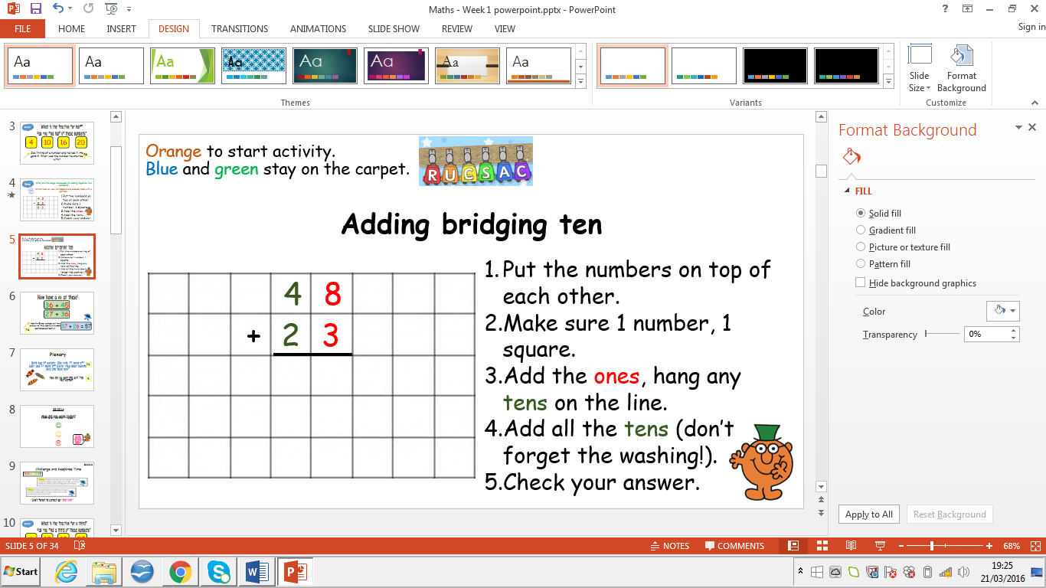

1

7

1