The Seaside | Week 1 | Week 2 | Week 3 | Week 4 | Week 5 | Week 6
 | English  Pretend you have been to the seaside. Write a postcard to a friend. | Art  Find out about Kandinsky. Write sentences about the artist.  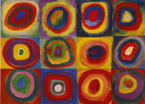 | Maths  Find 1/3 of 27, 30, 18, 24  Find half of 80, 34, 26, 16  Find a quarter of 16, 24, 32 and 40  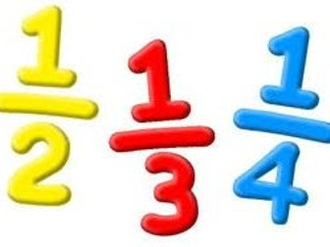 | History  How has the seaside changed over the years?  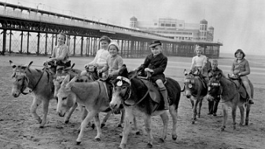 | English  Write a setting description of the seaside.  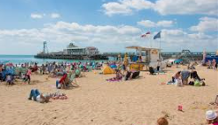 | Art  Find a piece of art linked to the seaside.  Try and recreate the art yourself  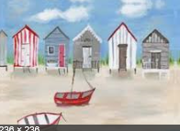
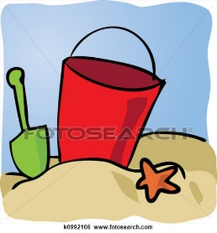 | Geography  Find and label a map of a seaside location with human and physical features  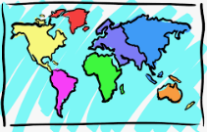. | Science  Take a flower or leaf and complete an observational drawing. Take your time to add lots of intricate detail. | English  Write a story set at the seaside. Bring it in to read with the class. | Design Technology  Design and make a moving picture set at the seaside.  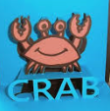 | History  Make puppets for your own Punch and Judy show.  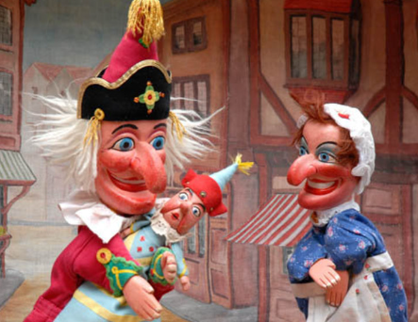 | Computing  Type a set of instructions for how to plant a seed.  