YEAR FOUR DOJO HOMEWORK – SPRING TERM 2
Homework activities for this half term are outlined below.
You will receive ‘Dojo Points’ for each task completed and at the end of the half term, your homework will be displayed in the hall for everyone to see.
If you complete all of the tasks, you will receive a homework celebration certificate and a bonus 10 dojo points.
When you complete a task, ask an adult to sign and date next to the task.
All tasks need to be completed and returned by Wednesday 1st April 2020 and parents will be invited to view work on Thursday 2nd April 2020.

HOMEWORK TASKS WORTH  1 DOJO POINT | HOMEWORK TASKS WORTH  3 DOJO POINTS | HOMEWORK TASKS WORTH  5 DOJO POINTS
Using a map, plan a walk around Crewe. | Sketch/paint your favourite place in Crewe. | Draw a map of Crewe. Remember to include a key.
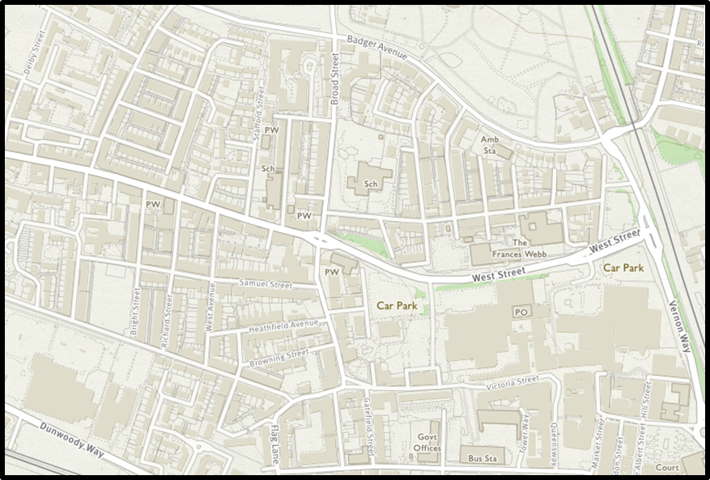  List as many places in Crewe you know, giving a sentence to describe them. | Plot a route from school to Queen’s Park using an ordnance survey (OS) map. | 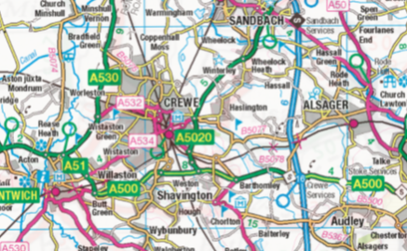  Design a model showing a place of your choice in Crewe.
