Home Learning – Week Beginning 29th June
 | Monday | Tuesday | Wednesday | Thursday | Friday
Literacy | Story: Three Billy Goats Gruff
 | Listen to the story, Three Billy Goats Gruff.  Talk about the characters.  Draw a story map for the story and label it.  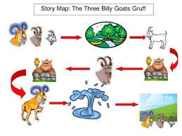 | Talk about the troll. Describe him, draw him and then, think about what might happen if the Billy Goats fall into the water? Can you write a sentence!  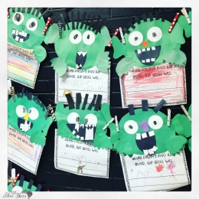 | We want the troll to like us and let us over the bridge. Maybe we could be his friend? What could we do?  Bake some biscuits!  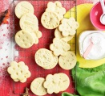  Talk about the ingredients, what do we need to do? Make the biscuits! | Think about trying to be friends with the troll, what nice things could we say? Could we tempt him by telling him the biscuits are delicious?  Write a message for the troll to encourage him to come back. Think about writing who it is to and from! | Listen to the story again, use different voices for the characters.  Cut out and make stick puppets, or you can draw / colour / cut your own. With a sibling or adult, can you re-tell the story of the Three Billy Goats Gruff using different voices?
Maths | Sharing (link to number bonds to 10)  Use counters or small objects, plastic toy food if you have some! Grapes, anything you like!  Count out 10,  Share it fairly between 2 goats, how many pieces do they get each? Find and explore all the ways of sharing 10 pieces of food between 2 goats.  Challenge: Can you write the sums (4+6, 6+4, 7+3 etc) | Doubling  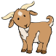  Goats in a field! Cut out the pictures of the goats. Put x number of goats into the first field, can you put the same amount in the second field? How many altogether? What is the sum? Record all the different ways of doubling number, up to 5+5. | Halving  Count out X number of goats out. Share them into two even groups. How many in each group? Talk about half.  Pick even numbers (2,4,6,8,10,12) Share them in  half, | Distance  Talk about distance, mention social distancing!  How far can you jump? Stand and mark who can jump the furthest distance in your family!  Throw a beanbag or object, who can throw the furthest distance? How can we measure it? | Distance  Talk about the language of distance, furthest, shortest distance. When objects land next to each other, think about the language; near, far, close, next to.  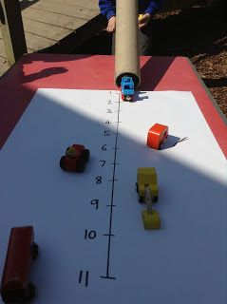  Have a go at something like this:
Other activities | 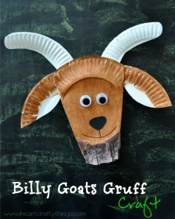  Can you make a goat? | Make a troll for the Literacy writing! | 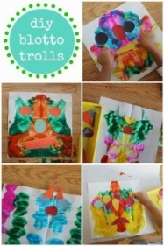  Paint half a troll, fold the paper and print it symmetrical! | Can you build a bridge for a goat or any small object to stand on?  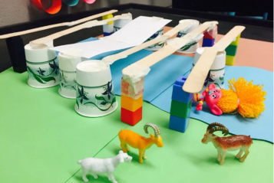 | 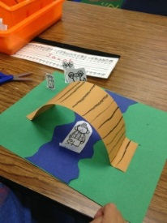  Create a billy goats gruff scene. Use it with your puppets!

Biscuits!

Ingredients:
- 200g unsalted butter, softened
- 200g golden caster sugar
- 1 large egg
- ½ tsp vanilla extract
- 400g plain flour, plus extra for dusting

Method:
- Heat oven to 200C/180C fan/gas 6 and line a baking sheet with baking parchment. Put the butter in a bowl and beat it with electric beaters until soft and creamy. Beat in the sugar, then the egg and vanilla, and finally the flour to make a dough. If the dough feels a bit sticky, add a little bit more flour and knead it in.

- Pull pieces off the dough and roll them out to about the thickness of two £1 coins on a floured surface. The easiest way to do this with small children is to roll the mixture out on a baking mat. Cut out shapes using a 9cm biscuit cutter, or a use the rim of a small glass and peel away the leftover dough around the edges. Press some clean toys gently into the biscuits, making sure you make enough of a mark without going all the way through. Re-roll off-cuts and repeat.

- Transfer the whole mat or the individual biscuits to the baking sheet and bake for 8-10 mins or until the edges are just brown. Leave to cool for 5 mins, then serve. Will keep for three days in a biscuit tin.

